Programming, and Data Structures

Workbook 6

This worksheet WILL be graded.

Today we are going to take a break from the compiler, and work directly from the pseudo code in the lecture notes on Binary Search Trees. Answer each of the questions below, and submit your answers as a PDF.

Before you begin.

1. Ensure that your workspace is in a folder which is backed up to the web/ network e.g. college network drive, google drive. You may like to have it in the following folder structure …/GriffithCollege/PDS/workspace
2. Make a new folder called Workbook0x

**/\***

**\* Use an application like draw.io for your diagrams. Handwritten**

**\* submissions will not be accepted.**

**\***

**\*/**

**\*\*\*\*\*\*\*\*\*\*\*\*\*\*\*\*\*\*\*\*\*\*\*\*\*\*\*\*\*\*Clarification for Q2\*\*\*\*\*\*\*\*\*\*\*\*\*\*\*\*\*\*\*\*\*\*\*\*\*\*\*\*\***

For part **e** and **f** there are two child nodes.

Use the following algorithm.

* Use the **Rightmost node** of the **Leftside** of the BST

*(Value to be deleted is on the left or the root).*

* Use the **Leftmost node** of the **Rightside** of the BST

*(Value to be deleted is on the right or the root when the left side of the tree is empty).*

For part **i**

* Read the Extra Reading slides to find out the Successor value of a node.

**Binary Tree**

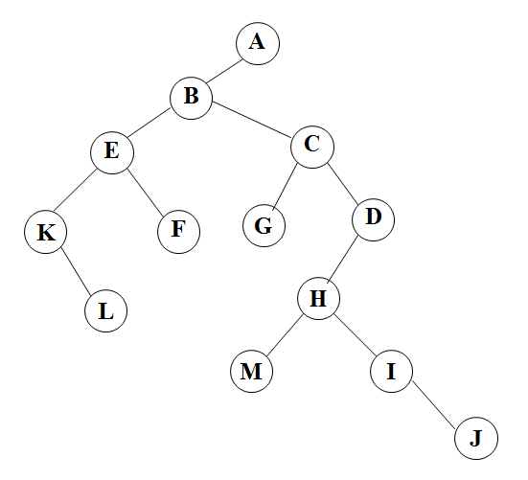

**Question 1:** Perform a postorder, preorder & inorder traversal of the binary tree above.

**Binary Search Tree**

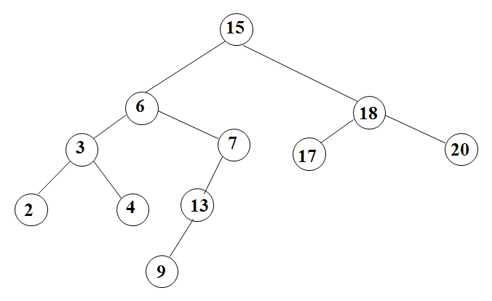

**Question 2**

1. Fix the tree above to ensure it is an actual Binary Search Tree and use this new tree to answers the questions below
2. Perform a postorder, preorder & inorder traversal of the above binary search tree.

For parts c) to i) ensure that you used the fixed binary search tree as the starting point for each question.

1. Insert the value 12 into the above BST (please redraw the entire tree)
2. Insert the value 22 into the above BST (please redraw the entire tree)
3. Delete the value 6 from the above BST (please redraw the entire tree)
4. Delete the value 18 from the above BST (please redraw the entire tree)
5. Delete the value 9 from the above BST(please redraw the entire tree)
6. Delete the value 13 from the above BST(please redraw the entire tree)
7. What is the successor to value 15 in the above BST?

**Question 3**

Draw the binary search tree that is created from inserting data in the following order. Start with the root node as 1 and then insert the values by asking the question “Is it greater or less than the current node?”.

1,12,9,18,17,19,4,5,3